Comments in C++

A well-documented program is a good practice as a programmer. It makes a program more readable and error finding become easier. One important part of good documentation is Comments.

* In computer programming, a comment is a programmer-readable explanation or annotation in the source code of a computer program
* Comments are statements that are not executed by the compiler and interpreter.

**In C/C++ there are two types of comments :**

1. Single line comment
2. Multi-line comment

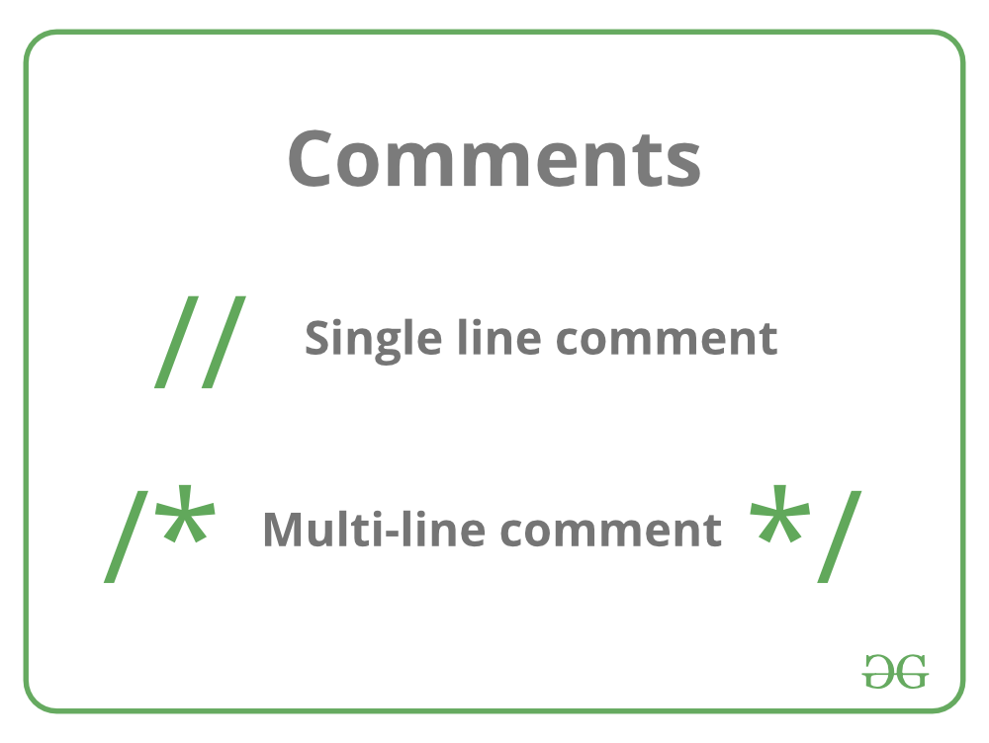

**Single line Comment**

Represented as  **//**  double forwardslash It is used to denote a single line comment. It applies comment to a single line only. It is referred to as C++-style comments as it is originally part of C++ programming.

for example:

// single line comment

**Example:**

C++

// C++ program to illustrate

// use of single-line comment

#include <iostream>

int main()

{

// Single line Welcome user comment

std::cout << "Welcome to GeeksforGeeks";

return 0;

}

**Output**

Welcome to GeeksforGeeks

**Multi-line comment**

Represented as **/* any_text */** start with forward slash and asterisk (/*) and end with asterisk and forward slash (*/).   
It is used to denote multi-line comment.

/*Comment starts

continues

continues

.

.

.

Comment ends*/

**Example:**

C++

/* C++ program to illustrate

use of

multi-line comment */

#include <iostream>

int main()

{

/* Multi-line Welcome user comment

written to demonstrate comments

in C/C++ */

std::cout << "Welcome to GeeksforGeeks";

return 0;

}

**Output**

Welcome to GeeksforGeeks

**Comment at End of Code Line**

You can also create a comment that displays at the end of a line of code. But generally its a better practice to put the comment before the line of code.   
**Example:**

int age; // age of the person

**When and Why to use Comments in programming?**

1. A person reading a large code will be bemused if comments are not provided about details of the program.
2. Comments are a way to make a code more readable by providing more description.
3. Comments can include a description of an algorithm to make code understandable.
4. Comments can be helpful for one’s own self too if code is to be reused after a long gap.